

Value-Based Payment Partner Request for Proposal

Issued June 11, 2025

Table of Contents

I. Introduction and Background 3
II. Request for Proposal Objective 3
III. Request for Proposal Timing 4
IV. Instructions for Respondents 4
A. Response Submission General Information 4
B. Response Format and Structure 5
V. Vendor Questionnaire 6
A. General Information 6
B. Partnership Philosophy 6
C. Solutions and Services Proposed for the OCHIN Collaborative 6
D. Systems Integration: 7
E. Clinical Care Model 7
F. Provider Enablement Services 7
G. Patient Engagement Services 8
H. Competitive or Conflicting Services 8
I. Analytics and Reporting: 8
J. Cost Reporting 8
K. Utilization Reporting 8
L. Compliance and Security 8
M. Implementation Plan and Timeline 9
N. Financial Viability 9
O. Customer Support 9
P. Exclusivity Clause 9
Appendix A: OCHIN Member and Patient Data Fact Sheet 10
Appendix B: OCHIN Value Based Care Services 12

Introduction and Background

Thank you for responding to our initial Request for Information. Through our review process we have narrowed the list of potential partners and are moving into a request for a formal proposal. This Request for Proposal (RFP) will inform OCHIN’s selection of a Value-Based Payment (VBP) Partner for the OCHIN Collaborative.

While we aim to remove redundant questions from the RFI to this RFP, we are including the OCHIN Overview and aim for your convenience and reference. OCHIN is a nonprofit leader in health care innovation, serving over 7.1 million patients across 300 organizations. With the largest collection of community health data in the country and over two decades of practice-based research, OCHIN provides clinical insights, tailored technologies (including the Epic EHR platform), data analytics, and research to expand patient access, improve outcomes, reverse chronic disease, connect care teams, and reduce the overall cost of care. The size and scale of the OCHIN network enables it to be a catalyst for care transformation. Currently, OCHIN is seeking a strategic payer partnership to enable FQHCs and Rural Health providers to advance their VBP engagements, improving shared savings and care for their populations.

Request for Proposal Objective

As a collaborative of over 2,000 care delivery sites in both urban and rural settings across 43 states, OCHIN members are seeking to expand their VBP engagements. OCHIN’s member Medicare population hosts roughly 200,000 traditional Medicare patients with an additional 2.7 million Medicaid patients. Please refer to the OCHIN Member Fact Sheet attached in Appendix A for additional member and patient population information.

OCHIN members have varying degrees of experience in Value Based Payment arrangements. Roughly 45% of OCHIN members are not currently involved in Medicare Fee for Service nor Medicare Advantage Plans value-based contracts. Twenty-five percent of members have experience in either Medicare Fee for Service (FFS) or Medicare Advantage (MA) value-based care contracts, but not both. The remaining 30% of members have experience with both Medicare FFS and MA plans.

OCHIN’s aim is to partner with an enabler who will be able to create one or more ACOs comprised of OCHIN members based on their readiness to enter into value-based payment arrangements. Based on the breakdown represented above, we anticipate needing to create an ACO for members who are new (newer) to Value Based Care, a second for those maturing in the space who plan to convert and/or broaden their experience but who are not yet ready to fully take on downside risk, and a potential third, for those who are more advanced but can reap additional benefits through joining an “OCHIN-ACO”. We look forward to your proposal to understand how you would recommend that this be achieved.

A successful partnership will:
- Provide services, solutions and capabilities that support the financial sustainability of community health care organizations
- Establish and optimize ACO models that maximize shared savings distribution and leading care outcomes to the benefit of OCHIN members
- Create flexible arrangements to meet the varying needs of OCHIN members
- Manage the financial risk and distribution of payment to OCHIN, any network or CIN partners, and OCHIN members.
- Incorporate OCHIN services and solutions into your model either through shared savings distribution, shared ownership, per member per year, or other compensation model proposals.
- Incorporate ownership opportunities for OCHIN, OCHIN Members or OCHIN Network/CIN partners.
- Leverage OCHIN’s relationship and partnership with our members to drive successful use of the EHR, OCHIN data and analytics, and other services provided by OCHIN to enable member success. Refer to Appendix B for Services Provided by OCHIN
- Allow OCHIN to be the primary ‘voice’ to the OCHIN members.
- Limit the use of external (non-OCHIN) tools necessary to drive successful management of patients.
- Integrate any systems, platforms or data sources with OCHIN’s portfolio to streamline process, analytics, and drive decisions to the end-user through OCHIN Epic.

Request for Proposal Timing

The timeline to complete the selection process is outlined below. The dates are subject to change at OCHIN’s discretion. OCHIN will make its best efforts to notify partners of any changes.

RFP Distributed to Vendors | Wed, 6/11/25
Partner confirm receipt of RFP | Thurs, 6/19/25
Partner Questions Due | Fri, 6/27/25
OCHIN Written Responses to Questions | Wed, 7/3
Partner RFP Responses Due | Thurs, 7/10, 5pm PDT
OCHIN Hosted Q&A Sessions | Between 7/23 and 8/1
OCHIN Board and Executive Steering Proposal/Reviews | August
Partner Selected and Notified | Fri, 9/12

Instructions for Respondents

Response Submission General Information

The partner response should include narrative responses to the questions below. Please be concise in your reply and avoid adding additional collateral or marketing materials. All components of the RFP must be completed as directed; failure to do so may result in your response being removed from consideration.

Responses must be completed and submitted electronically in the file format specified below by 5 PM PDT July 10th to:

Kenzie Williams
Manager of Procurement
503.943.2500
williamsk@ochin.org
procurement@ochin.org
OCHIN Inc.
P.O. Box 5426
Portland, OR 97228

All material submitted becomes the property of OCHIN and will not be returned. All proprietary information provided by vendors must be marked clearly as confidential and will be treated as such.
All inquiries concerning this document and/or process should be sent to Kenzie Williams at williamsk@ochin.org and CC Procurement@OCHIN.org by June 20, 2025.

Response Format and Structure

Vendors are required to submit their electronic responses to the following in format specified:
Responses to Vendor Questionnaire (below)
- Provide the appropriate responses, including narrative descriptions as necessary, to each question. Be concise; do not add extraneous, lengthy marketing material.
- When submitting the response to OCHIN, both PDF and Word formats are acceptable. Please do not convert your responses to PowerPoint or other documentation format.

- Withdrawal of Proposals

A Proposer may withdraw their proposal (RFP response) before June 20th, 2025 by sending a written request for withdrawal signed by, or on behalf of, the Proposer to: Kenzie Williams (williamsk@ochin.org and CC Procurement@OCHIN.org)

- Non-Disclosure

As part of the RFP response process the enclosed Mutual Non-Disclosure Agreement (NDA) between the vendor and OCHIN must be completed by June 20th, 2025 and returned to Kenzie Williams (williamsk@ochin.org and CC Procurement@OCHIN.org).

Vendor Questionnaire

Please answer each question completely, concisely, and accurately.

General Information
- Organization Information
  - Company Name
  - Corporate Headquarters (address, city, state, country)
  - Website:
  - Public or Private (if public, provide stock ticker symbol)
  - What is the geographic reach of your current VBP portfolio:
  - Indicate any pending litigation

- Primary Contact:
  - Name:
  - Title:
  - Phone Number:
  - Email:

Partnership Philosophy
- Describe your preferred partnership model and the attributes you require for shared success

- Describe how you will structure and support shared ownership and partnership models for OCHIN, OCHIN Members (Customers), and OCHIN Network/CIN partners?

- Describe the longest and average tenure of your strategic value-based partnerships

- Describe the key benefits customers gain by partnering with your organization for ACO models and describe the top five reasons or use cases that consistently lead customers to engage your services, solutions and capabilities.

- Please share when you have worked with provider networks who preferred to be the primary point of contact to the network? How have you navigated that relationship? Has it been successful? Why or why not?

Solutions and Services Proposed for the OCHIN Collaborative
- Describe your proposal for meeting the varying needs and experience levels of the OCHIN membership as outlined in the Fact Sheet in Appendix A.

- Describe the depth and breadth of your services, solutions and capabilities supporting the financial sustainability of community health care organizations

- Providers want to provide a consistent high-level of patient care across all they serve. How does your approach support broader population health management, while also addressing payer specific performance?

- What measurable outcomes have you helped your customers achieve in terms of economies of scale, time and resource savings, care quality leadership and/or care delivery transformation and money earned or saved. Please provide three FQHC references that can attest to these results. Please provide financial and quality results over time.

Systems Integration:
- Describe how you will ensure that this solution optimizes the use of the services provided by OCHIN to the members (customers) who will participate in this ACO arrangement.

- Describe how your solution supports a unified data platform that integrates across payers and programs.

- Do you require health centers to implement or use any platforms for care coordination or patient outreach purposes? If yes, please explain.

- Indicate any third-party vendors or components that are necessary or optional to use with your model.

Clinical Care Model
- Please describe your proposed clinical care model, including key components and how it supports value-based care and shared savings. Include any fees or reductions in shared savings.

- Provide examples of how your care model has improved patient outcomes and demonstrated shared savings.

- What strategies does your care model employ to enhance care coordination among different healthcare providers?

- How does your care model address the management of chronic diseases and high-risk patient populations?

- What preventive care measures are integrated into your care model to reduce long-term healthcare costs?

Provider Enablement Services
- What types of provider enablement services do you provide (i.e. Provider Education, Patient Education, Funding for EHR/Technology updates, etc.)

- Do you offer provider and health center education or resources around coding strategy and risk adjustment in value-based care? Especially in CHCs?

- Do you provide any funding/financial support for providers to obtain technology or tools need to support care management and coordination?

- Do you provide executive education regarding successful performance in ACO models? If yes, please explain.

Patient Engagement Services
- Do you provide patient engagement services? If yes, how are these efforts documented and shared with providers?

- What infrastructure or services do you provide to support the integration of social services (e.g. access to healthy food, transportation, housing)?

Competitive or Conflicting Services
- Please include any competitive services that would not align with the partnership with OCHIN or are required by Provider Participants and may compete with services provided by OCHIN.

Analytics and Reporting:
- What analytics capabilities does your solution offer to track performance metrics and generate reports? How is this information shared with providers?

- Outline how your solution will integrate with OCHIN Epic build and workflows (eliminating the need for providers to access external systems for patient lists, metrics, and care measures)?

Cost Reporting
  - What tools and features does your solution offer for analyzing and reporting on healthcare costs? How is this information shared with providers?

  - How does your solution help identify and achieve cost savings in value-based payment models?

  - Does your solution support budgeting and forecasting healthcare costs? If so, please describe how.

Utilization Reporting
- What key utilization metrics does your solution track and report on?
- How does your solution help identify and analyze trends in healthcare utilization?
- Does your solution offer benchmarking capabilities to compare utilization against industry standards or peer groups?
- How customizable are the utilization reports generated by your solution? Can users create custom reports based on specific needs?
- How is this information shared with providers and practices?

Compliance and Security
- What measures do you have in place for data storage, security, and compliance with regulations like HIPAA?
- How does your care model comply with other relevant healthcare regulations and standards, including HL7/FHIR, and SOC2 Compliance?
- You will be asked to complete an OCHIN Security Assessment as part of our selection process, please indicate if this will cause any barriers or delays.
- Security:
  - What security measures does the system use?

  - Does the system provide audit user access to patient data for HIPAA compliance?

  - Is the system capable of restricting user access to patient data by group membership?

  - Is the system capable of restricting user access to various features based on roles?

Implementation Plan and Timeline
- Please share the standard provider implementation timeline, including owners of workflows and other time and personnel requirements for implementation.
- Please provide an understanding of the data collection and systems requirements needed during an implementation including interfaces and data integrations.
- Please provide an understanding of the resources that would be needed from OCHIN and / or from the community health center partners during the implementation.

Financial Viability
  - Please provide a cost-benefit analysis to demonstrate the potential return on investment.

  - What is the provider gainshare in your model?

  - Is your organization open to a non-traditional or more strategic partnership?

Customer Support
  - Please provide information about your customer service model.

Exclusivity Clause
  - What are your exclusivity clause criteria and requirements?

- References
  - If you did not previously provide at least three references as part of your RFI response, please do so below including the following information:
    - Organization name
    - Organization type
    - Products/Modules Implemented
    - Key contact and title
    - Phone number
    - Email

Appendix A: OCHIN Member and Patient Data Fact Sheet

Approximate health center membership as well as patients across OCHIN network:
Members | Commercial | Medicaid | Dual Enrollees | Medicare FFS | Medicare Advantage | Other Public | Uninsured
230 | 1,000,000 | 2,750,000 | 6,500 | 240,000 | 240,000 | 20,000 | 1,000,000

Approximate health center membership patient averages across OCHIN network:
Commercial | Medicaid | Dual Enrollees | Medicare FFS | Medicare Advantage | Other Public | Uninsured
4,200 | 12,000 | 28 | 1,000 | 1,000 | 100 | 4,500

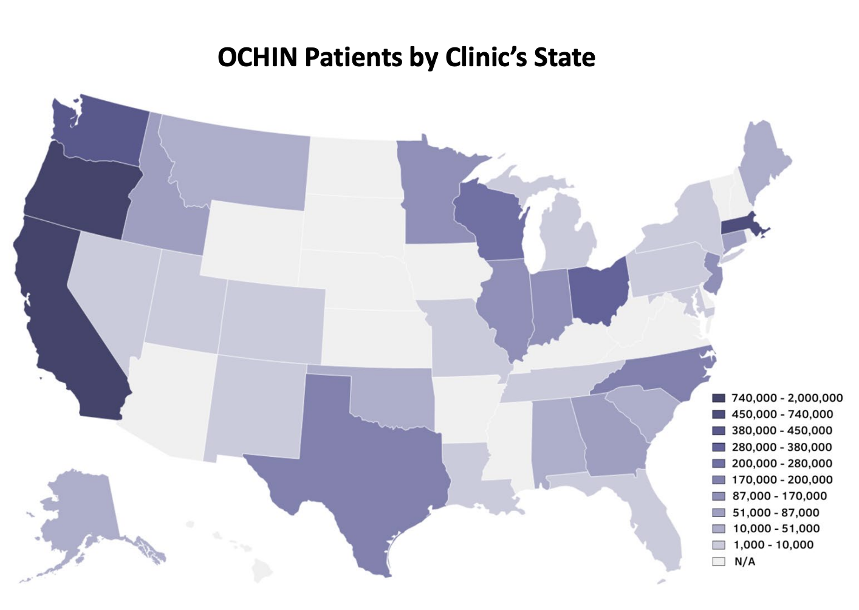
OCHIN members have varying degrees of experience in Value Based Payment arrangements. Roughly 45% of OCHIN members are not currently involved in Medicare Fee for Service nor Medicare Advantage Plans value-based contracts. Twenty-five percent of members have experience in either Medicare Fee for Service (FFS) or Medicare Advantage (MA) value-based care contracts, but not both. The remaining 30% of members have experience with both Medicare FFS and MA value-based care contracts.

Top five Medicare states (all types):
- California ~125,000
- Oregon ~60,000
- Massachusetts ~ 35,000
- North Carolina ~ 30,000
- Wisconsin ~20,000

OCHIN’s Network Partnerships
- OCHIN Partners with many state and local PCAs and CIN networks across our membership. Some of these network partners are involved in Value-based arrangements with community health centers who utilize OCHIN Epic. In these markets, it will be important to include these networks in the design of our future model.

Appendix B: OCHIN Value Based Care Services

For further reference, we are including a short-list of solutions OCHIN currently provides that support providers in value-based care arrangements. Please incorporate your understanding of the use of these solutions into your proposed offering.

- Epic EHR | - Epic Payer Platform | - MyChart Patient Portal
- Roster Management Engine | - Value Based Performance Management (VBPM) - Certified HEDIS Measures, Cost and Utilization Metrics | - Compass Rose Enhanced Care Management Programs
- Healthy Planet Platform for Risk Stratification, Care Management & Patient Outreach | - Data Ingestion Normalization Engine (DINE): Claims Ingestion | - Claims Engine
- Practice Transformation Services | - Workflow Consultation | - Social Service Resource Locator through UniteUs or FindHelp Native+
- Revenue Cycle Management Services | - Credentialing Services | - HIE with over 640 million clinical summaries exchanged
- Coding & Education Services | - Compliance | - Data Analytics

